Monitoring Task

Created Linux EC2 machine:
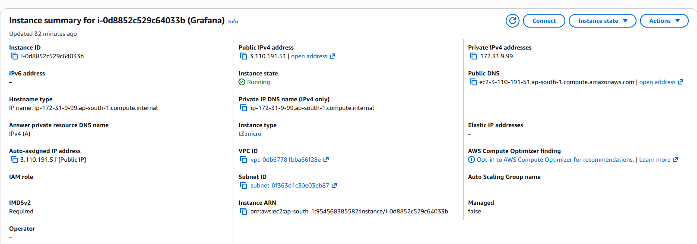

Prometheus installed on Linux machine:
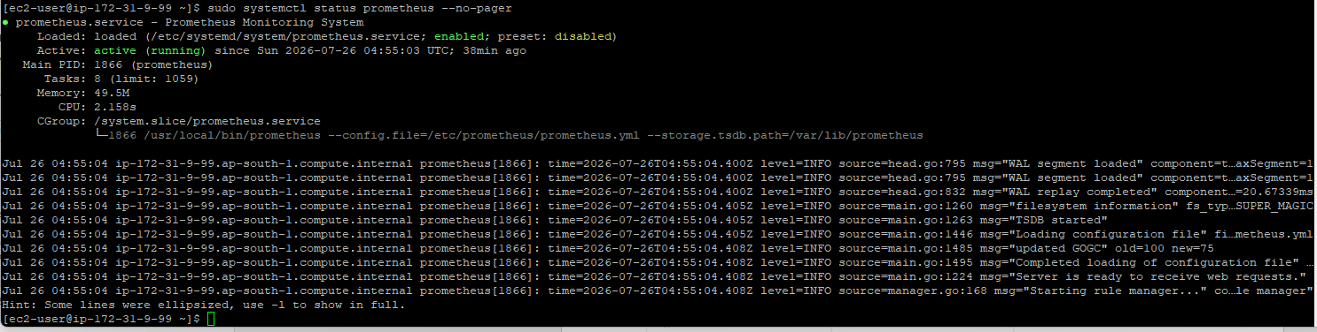
Grafana installed on Linux machine:
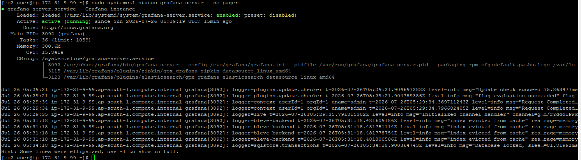

Connected Prometheus to Grafana:
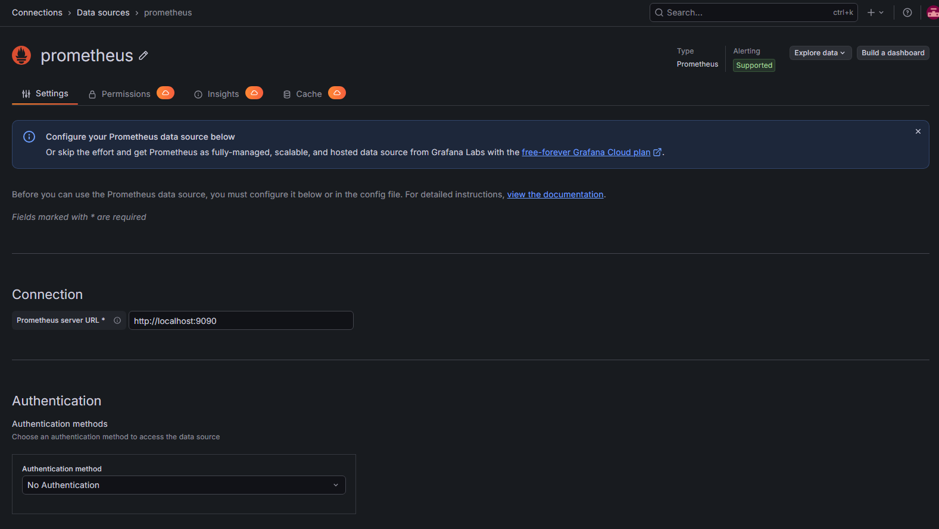

Created a dashboard to view metrics:
